Part 1: Object Oriented Programming in Python

Introduction  This tutorial aims to provide a clear introduction to the main concepts of object, class, and instance. To further enhance understanding, a variety of examples will be shown, to demonstrate the process of creating a class, an object instance, and constructors. | Required Software  For this tutorial, you will need access to the following software applications:  Visual Studio code + Python

What is an Object?
In general, an object is a tangible or visible thing that can be perceived by the senses, has a specific form, and can be interacted with.
Object can be a physical object or nonphysical object. A physical object is something that has a material existence like a book, a ball or a desk. A nonphysical object can refer to the aim or purpose. In computer programming objects are considered nonphysical type, however, often modelled after real-world physical objects. Therefore, in computer science an object can be defined as “An instance of a class and it encapsulates both data (attributes or properties) and the behaviours (methods or functions) that operates on that data.
Following are some examples of object
 |  |  |  |  |  | 
An apple fruit (Object) |  | A pear fruit (Object) | A Mitsubishi car (Object) |  |  | A Toyota car (Object)
 |  |  |  |  |  | 
British Airline flight (Object) |  | Air India flight (Object) | A person – Student (Object) |  |  | A person – professor (Object)
You can see that there are several objects in above rows like fruit, cars, flights and person. So, let’s group objects based on their type of nature.
 |  |  | 
Fruit - Objects |  |  | Car - Objects
 |  |  | 
Flight - Objects |  |  | Person - Objects
Remember Object has Attributes (data) and Methods |  |  | 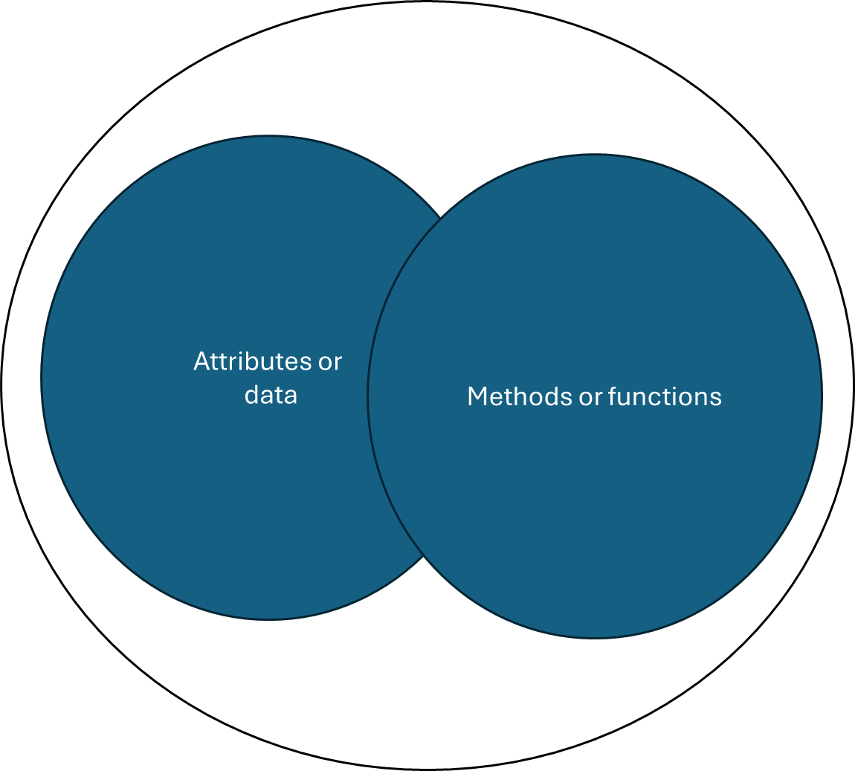
Now we group have group the several objects according to their features and class. So now let’s understand what is class
What is a Class?
A class is a template or blueprint to represent objects; class is also used to create objects. In summary a class outlines the structure and behaviour that objects created from
How can we create a class in Python?
- Open Visual Studio Code > File > New File > in search bar select Python File.  - Write code as shown in the right and save file (ctrl+S). For example, I’ve given the file name flight.py  - Class is a keyword to recognise that it is class by the python interpreter. Flight is a name of class that we have created. The pass statement acts as a placeholder for future code. If there is no code within a class definition, pass must be used. Otherwise, a SyntaxError will occur. Please note that “#” symbol can be used for the comments as shown at Line 1.  4. Run your first program with ctrl+F5 short cut key.  Please note that you will not get any output as we have not added anything yet to be shown on the terminal. |  |  |  |  | 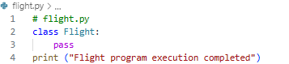
 | Task: Create a Car class similarly as Flight class in a new python file and run it. The output should be shown as below.
 | Task: Create a Fruit class similarly as Flight class in a new python file and run it. The output should be shown as below.
 | Task: Create a Person class similarly as Flight class in a new python file and run it. The output should be shown as below.
How can we add attributes (data) in the Class?
Working in flight.py  In our flight class let’s add an attribute for flight id.  As now we have added an attribute into the Flight class, therefore, we don’t need pass statement.  So now flight class has one attribute called as id which holds the value for flight is which is “FN123” |  |  |  | 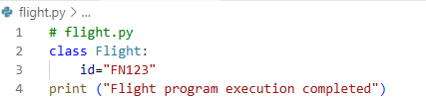
How to create object and access the class attributes such as id?
At line 4, an instance (also known as an object) of the Flight class is created: f = Flight (). This initializes the object, making it ready for use.  After the object f is created, its attributes can be accessed using the dot operator (.). In this case, f.id is used to access the id attribute of the Flight object.  Run the code and observe the output. |  |  |  | 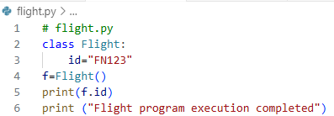
So, let’s add few more attributes (we can also call attribute as data or class variables). The new attribute are from, to and date. This time we will also import datetime library for the flight date time representation.  Why use from_ instead of from? Because from is a Python keyword, so we use from_ to avoid syntax error.  Run the code and see the output as below  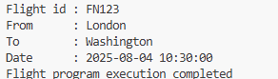 |  |  |  | 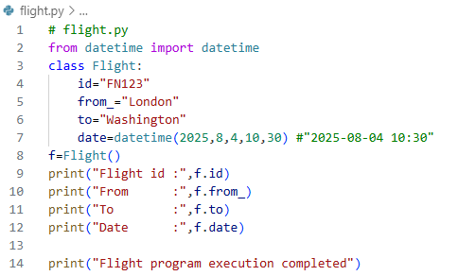  Figure 1

 |  | Task: Working in Car class add attributes and print those attributes.  # Include attribute for type of car such as SUV, hatchback etc  # Include attribute make such as Mitsubishi, Ford, etc.  #inlcude attribute model year and month such as 2020/08, etc.  #inlcude attribute speed  # Create object of Car class  #print attributes in a beautiful format  Run the code, your output should be like as shown in the right side. | 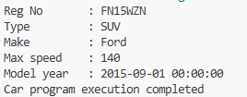  Figure 2
 |  | Task: Working in Fruit class add attributes and print those attributes.  # Include attribute for name of fruit such as Apple, Bana, Grapes  # Include attribute sweetness level between 1 and 10, 10 means sweetest.  #inlcude attribute for readiness such as ripe (true or false)  #inlcude origin attribute like from which country it is originated  #Include year, month, day, time of harvesting  # Include attribute best before as date time  # Create object of Fruit class  #print attributes in a beautiful format  #Run the code  Run the code, your output should be like as shown in the right side. | 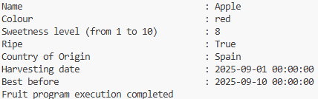  Figure 3
 |  | Task: Working in Person class add attributes and print those attributes  # Include attribute for firstname such as Louise  # lastname such as Wood  #- date of birth  # country of birth  #Nationality  # address  #print attributes in a beautiful format  Run the code, your output should be like as shown in the right side. | 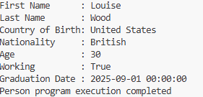  Figure 4
When defining classes such as Flight, Car, Fruit, or Person, attribute values are initially assigned directly within the code. This approach works well for a single object but presents challenges when working with multiple objects of the same type, such as numerous car models or fruit varieties.
While duplicating and modifying existing code in the class for each additional object may seem feasible, this practice can become unsustainable as the number of objects grows. Consider the need to store information for thousands of cars or flights; manually creating and maintaining separate code blocks for each would be inefficient and prone to error.
To address this, a more dynamic approach is necessary, where attribute values can be provided at runtime instead of being hardcoded. The __init__ method in Python provides precisely this mechanism. In object-oriented programming, this method is analogous to a constructor in languages like Java.
_init_ () method
In Python _init_ method is a special function; it is also known as constructor and is automatically called when a new object is created from a class.
Key Points about __init__:
- It initializes (sets up) the object’s attributes.
- It’s called automatically when you instantiate (create) an object.
- The first parameter is always self, which refers to the current instance of the class
- The _init_ method is designed to initialise attributes specific to an object instance, not the class as a whole
It’s time to play with _init_ method, for this we refactor our Flight example shown in Figure 1.
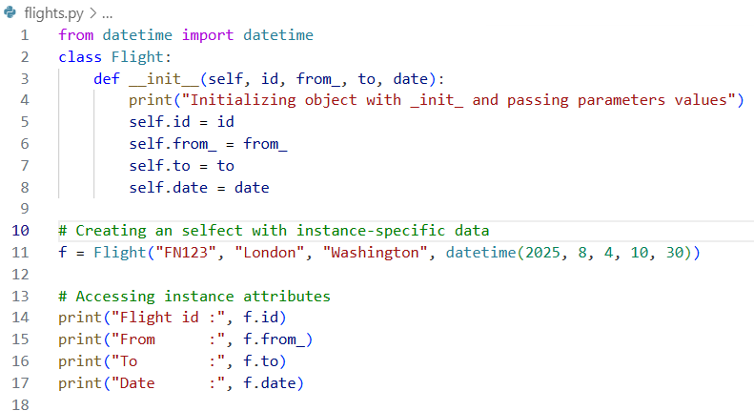
Figure 5
At line 3 to 8 we have defined the _init_ method that is called automatically when a new object (line 11) executes. The previous attributes now are parameters in the init method. Parameters: id, from_, to, and date are passed when you create a Flight object. self.id = id, etc.: These lines create instance attributes tied to the specific object (self refers to the current object).
Line 11 f = Flight("FN123", "London", "Washington", datetime(2025, 8, 4, 10, 30)) creates a new object of Flight class, please remember previously we created object without any parameters but here we have used Flight object with parameters in order to pass values to the __init__ method to set id, from_, to, and date.

Run the code and observe the output.
Everything runs well, change self to something else like obj and run the code again.
--
--
Yes, your code will run with obj as self is not a keyword just a naming convention, however, It must be the first parameter of any instance method (like __init__), though it can be named anything.

 | Task: Working in Car class, refactor the car example by using _init_ method like Flight refactoring example shown in Figure 5 and show the completed code to your tutor.  Make sure the output of your code is similar to Figure 6. |  |  | 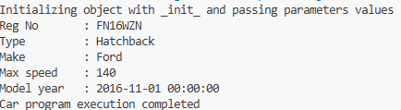  Figure 6
 | Task: Working in Fruit class, refactor the car example by using _init_ method like Flight refactoring example shown in Figure 5 and show the completed code to your tutor.  Make sure the output of your code is similar to Figure 7. |  |  | 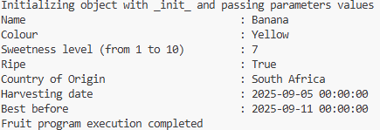  Figure 7
 | Task: Working in Person class, refactor the car example by using _init_ method like Flight refactoring example shown in Figure 5 and show the completed code to your tutor.  Make sure the output of your code is similar to Figure 8. |  |  | 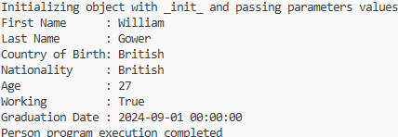  Figure 8
As you see our Flight class code shown in Figure 5 is not looking good as we have used print function 4 times to print data, Can we do this with single line of code. This will also print attributes of that instance of object automatically when an object is created. This magic will come through _str_() method.

The __str__() method is a special method in Python that defines how an object is represented as a string for human consumption. When print() or str() is used on an object, Python automatically calls its __str__() method (if defined) to generate the output. This allows a single line of code within the class to dictate how an object's attributes are presented when printed.

__str__() method we used here to control how an object appears when printed. It is automatically called by print (f) statement at line 20.
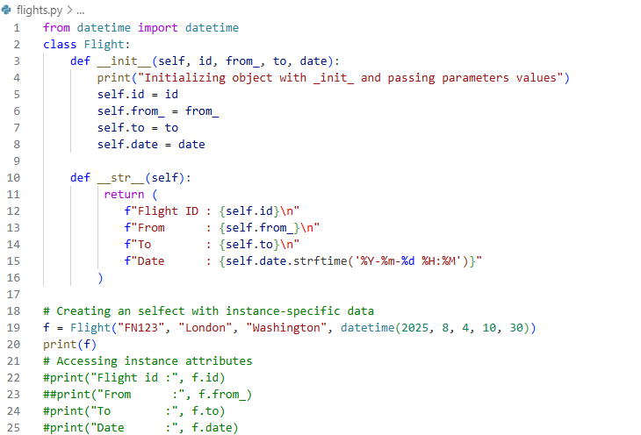
Figure 9
Run the code and observe the output.

Task: Can you create more flight objects and add code in Figure 9 and observe the output. For example, return flight
Add more flights like this and run and observe the code.
 | Task: Working in Car class, refactor the car example by using __str__() method like Flight refactoring example shown in Figure 9. Show the completed code to your tutor. Make sure the output of your code is similar to Figure 10.  There are several ways to pass parameter values when creating an object in Python. You can use positional arguments, where values are provided in the exact order of the constructor parameters; keyword arguments, where each value is explicitly associated with its parameter name for clarity and flexibility; or assign attributes after creating an empty object, which allows setting or modifying values dynamically after initialization.  Hint: Create a Car object and pass parameter values like this: |  |  |  | 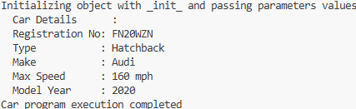  Figure 10
 | Task: Working in Fruit class, refactor the car example by using __str__() method like Flight refactoring example shown in Figure 9. Show the completed code to your tutor. Make sure the output of your code is similar to Figure 11.  Hint: Create a Fruit object and pass parameter values like this: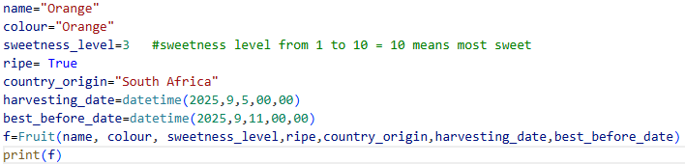 |  |  |  | 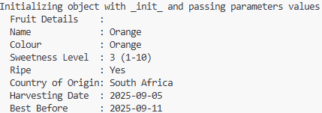  Figure 11
 | Task: Working in Person class, refactor the car example by using __str__() method like Flight refactoring example shown in Figure 9. Show the completed code to your tutor. Make sure the output of your code is similar to Figure 12.  Hint: Create a Person object and pass parameter values like this: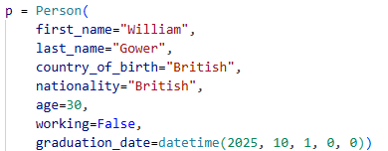 |  |  |  | 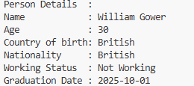  Figure 12

